Exploring Prime Numbers

on Your PC and the Internet with directions to

Prime Number Sites on the Internet
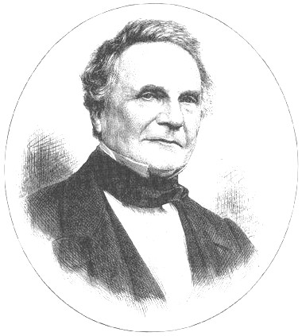
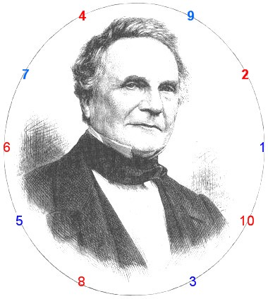
Charles Babbage, 1792-1871
Creator of Difference & Analytical Engines
See Carlos Rivera’s Puzzles 176, 359
ehp
Enoch Haga PUBLISHER
Folsom, California USA
First Revised Edition 2007

